
DIGITAL ASSIGNMENT 4

Name: Soumyadeep Ganguly
Reg No: 24MDT0082
Course: Big Data Analytics Lab
Course Code: PMDS507P

Explain the procedure to run the Hadoop WordCount program using the in-built mapreduce-examples.jar.

Step 1: Start Hadoop Services
First, we start the necessary Hadoop daemons for both the Distributed File System (DFS) and the resource manager (YARN).
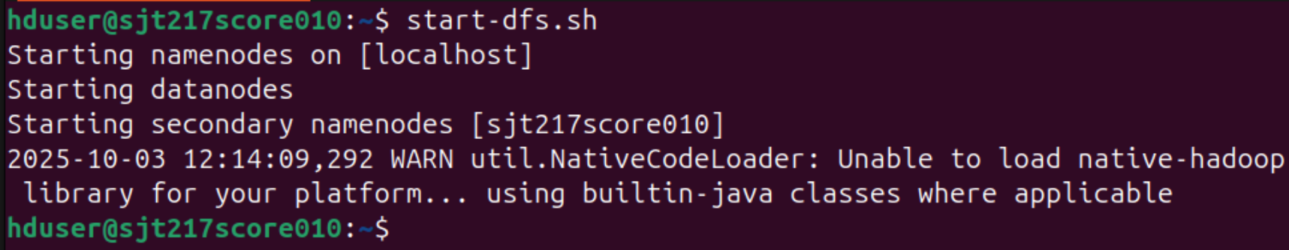
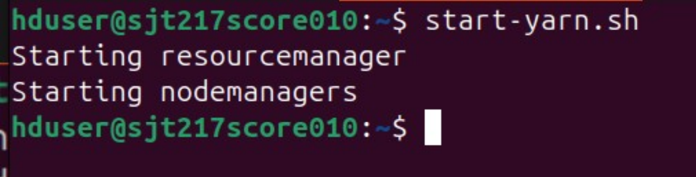

Step 2: Verify Daemons are Running
We use the jps (Java Virtual Machine Process Status) command to confirm that all required Hadoop processes have started successfully
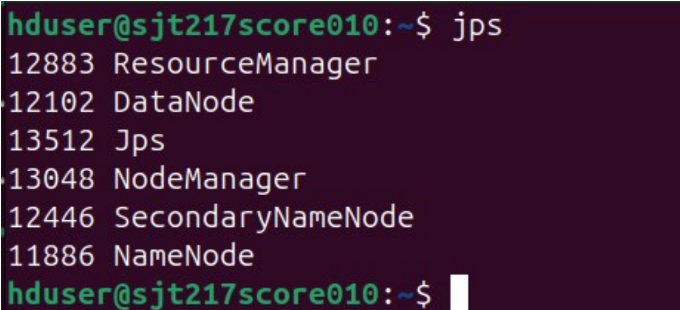
Step 3: Create an Input Directory in HDFS
Next, we create a directory named /input within the Hadoop Distributed File System (HDFS) to store our source text file.
Step 4: Upload the Input File to HDFS
We then copy the text file IntroToHadoop.txt from the local filesystem to the newly created /input directory in HDFS.
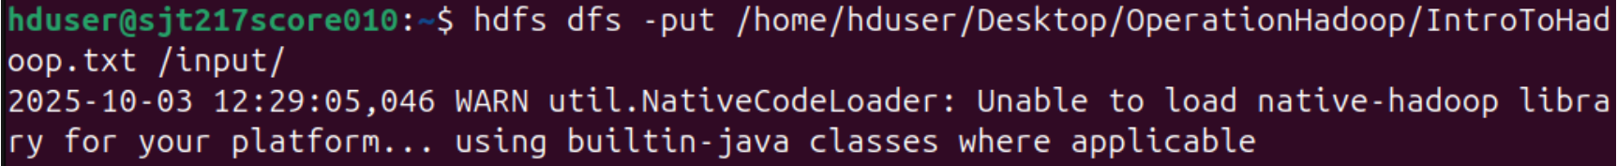
Step 5: Verify File Upload and Content
We list the contents of the HDFS /input directory to confirm the file exists and then use the cat command to display its content, ensuring it was uploaded correctly.
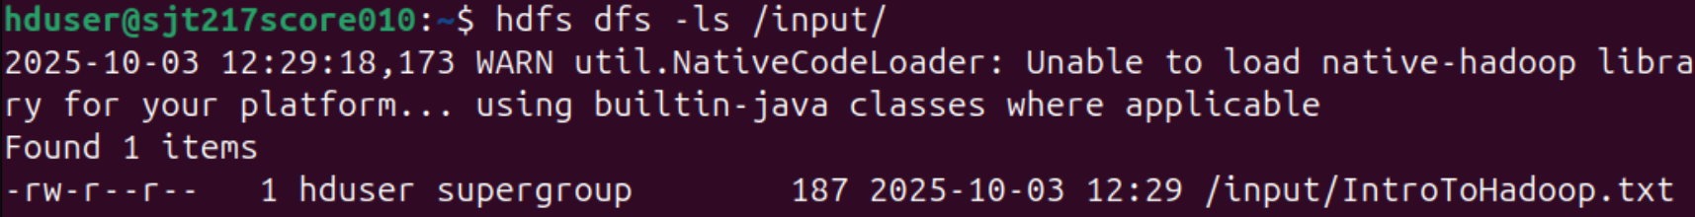

Step 6: View file contents:
Using –cat command we can view the file contents
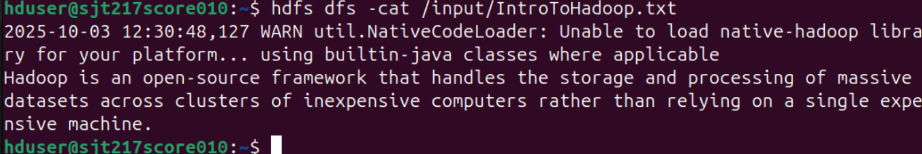
Step 7: Execute the WordCount MapReduce Job using JAR file
Now we execute the WordCount program using the hadoop jar command, specifying the example JAR file, the class wordcount, the HDFS input path /input, and the HDFS output path /output.
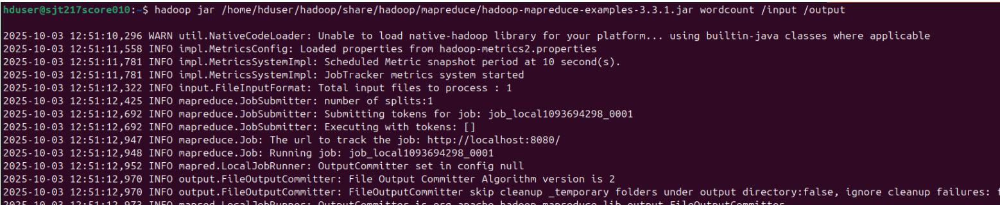

Step 8: View the Final Output
Finally, we use the cat command to view the contents of the output file part-r-00000 created by the MapReduce job in the /output directory, which contains the final word counts.
